Homework Exercise 1

Shan He

Sep 7, 2017

# W203 Statistics for Data Science

# Unit 1 Homework

## Exercise

Load the dataset found in the file, cars.csv.

cars = read.csv("cars.csv")

1. What are the variables in the file?

names(cars)

## [1] "mpg" "cyl" "disp" "hp" "drat" "wt" "qsec" "vs" "am" "gear"  
## [11] "carb"

1. Find the mean, median, minimum, maximum, 1st quartile and 3rd quartile for the mpg variable.

summary(cars$mpg)

## Min. 1st Qu. Median Mean 3rd Qu. Max.   
## 10.40 15.20 18.70 19.49 21.50 33.90

1. Create a histogram of the mpg variable.

hist(cars$mpg, main = "Histogram of MPG", xlab = "MPG")

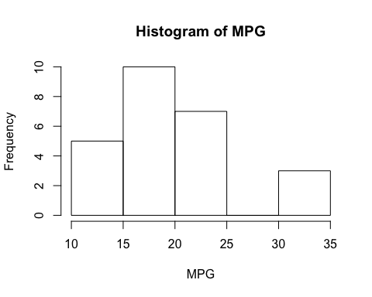

1. What is the standard deviation of mpg variable?

sd(cars$mpg)

## [1] 6.047446

1. What is the variance of mpg variable?

var(cars$mpg)

## [1] 36.5716

1. What is the relationship of the standard deviation to the variance? Why does the standard deviation and variance of the mpg variable differ?

sd(cars$mpg) == sqrt(var(cars$mpg))

## [1] TRUE

The standard deviation is the square root of the variance.

1. How many data points are there for the cyl variable?

sum(!is.na(cars$cyl))

## [1] 23

1. What is the mean of the cyl variable?'

Case 1: When the mean should be 'NA' if there is any empty entry

mean(cars$cyl)

## [1] NA

Case 2: When the mean should be the mean of all non 'NA' values

mean(cars$cyl, na.rm = TRUE)

## [1] 6.26087